R wave

Function IN2A_CalculateRWave(df)

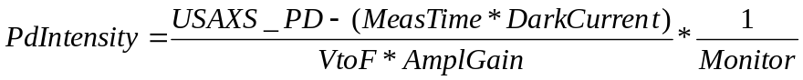

Removed originally:
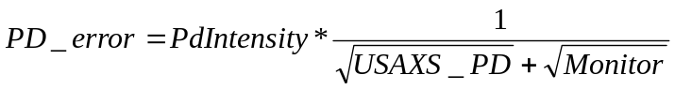, we know, that this is not correct formula for the error, but do not have better.

This is new formula, much more complex:
Duplicate/O PD_Error, SigmaUSAXSPD, SigmaPDwDC, SigmaRwave, SigmaMonitor, A

SigmaUSAXSPD=sqrt(USAXS_PD*(1+0.0001*USAXS_PD))
UPD error esxtimate is Poission dist (sqrt(UPD) + 1% of UPD value

SigmaPDwDC=sqrt(SigmaUSAXSPD^2+ErrorParameters[pd_range-1]^2)
We measure the UPD dark current error, so we add it on…

SigmaPDwDC/=(VToFFactor*LocalParameters[pd_range-1][0])
Here we divide it by proper value conversion parameter

A=(USAXS_PD - MeasTime*LocalParameters[pd_range-1][1])*(1/(VToFFactor*LocalParameters[pd_range-1][0]))

This is needed for error propagation calculation…

SigmaMonitor=sqrt(Monitor)

SigmaRwave=sqrt(A^2*SigmaMonitor^4+SigmaPDwDC^2*Monitor^4+(A^2+SigmaPDwDC^2)*Monitor^2*SigmaMonitor^2)
SigmaRwave/=Monitor*(Monitor^2-SigmaMonitor^2)
The above is the calculation of the error for division…

PD_error=SigmaRwave
This results I higher errors (minimum 1% of R_Int value), which increases with the decrease of the intensity…

Function IN2A_FitLorenzianTop
K0=0
CurveFit/H="1000" Lorenzian with baseline fixed to 0
Baseline=W_coef[0]=0
BeamCenter=W_coef[2] [degrees]
MaximumIntensity=W_coef[1]/W_coef[3] [counts]
PeakWidth = sqrt(W_coef[3])*2 [degrees]

Function IN2A_FitGaussTop
K0=0
CurveFit/H="1000" Gaussian with baseline fixed to 0
Baseline=W_coef[0]=0
BeamCenter=W_coef[2] [degrees]
MaximumIntensity=W_coef[1] [counts]
PeakWidth = W_coef[3]*2*ln(2) [degrees]

Function IN2A_CreateLogLogPlot()

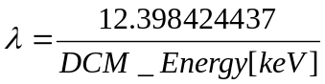 [A]

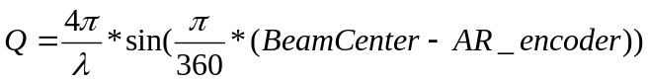 [A⁻¹]

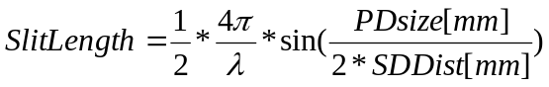 [A⁻¹]

Subtract blank from sample

USAXS calibration

[arc seconds]

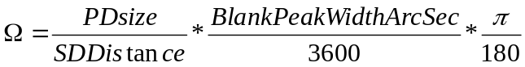

, 0.1 converts the sample thickness from mm to cm.

SBUSAXS calibration, width given by rocking curve width

AsStageWidth is assumed to be same as BlankPeakWidth, user can overwrite both values.
comment: it seems, that proper DSM calibration should include factor of 1.53(?) to account for the use of single bounce sidebounces…

, 0.1 converts the thickness from mm to cm…

No calibration

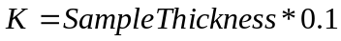
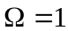

Corrections for transmissions and peak shift for Subtract Sa & Blank

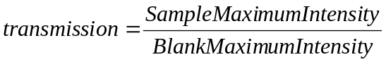

USAXS

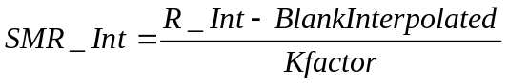

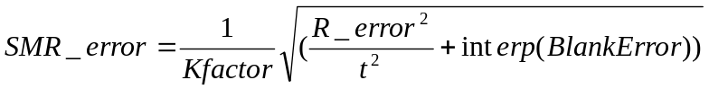

SBUSAXS - create DSM data

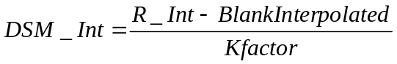

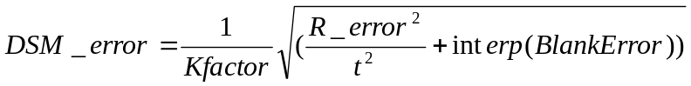

Note, that the Q shift is shifting the sample data with respect to blank, which is considered fixed…

MSAXS correction

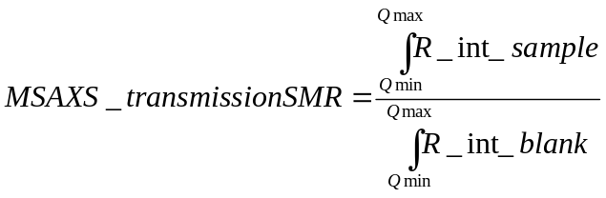

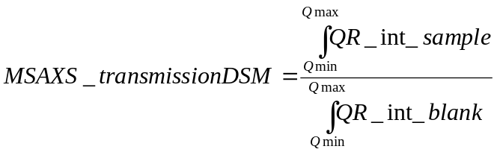

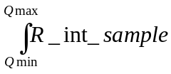,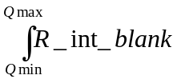,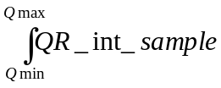,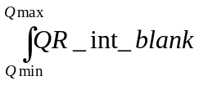 use Igor areaXY function, which uses trapezoidal function. The missing Q range on the “short” side is replaced by range from the other side…

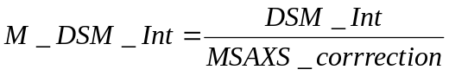
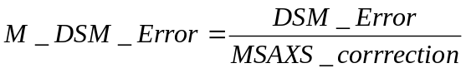
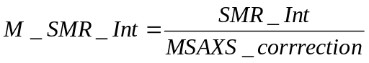
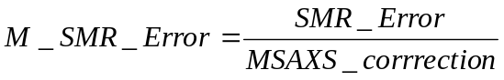

Anisotropic MSAXS problem:

Evaluate all anisotropic data for all sectors, the results are stored in the waves (numeric “MSAXSResults” and text “MSAXSFolder”, both in root:Packages:MSAXSCorrection). These waves can be edited before the correction is applied…
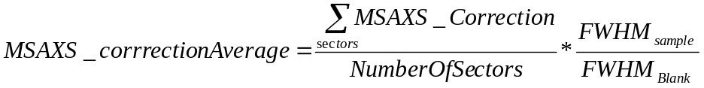

note, that this increases overall correction and should correct properly for anisotropic effect, since the slit width is actually quite wide for the sample. Added on March 25 2003. I wish I had an idea, if this is correct…

